**Homework 10 Submission**

**Name:** Danigan Keecha-Milsom

**Student ID:** 29715415

**Lab:** 12

**Tutor:** Frank Fan

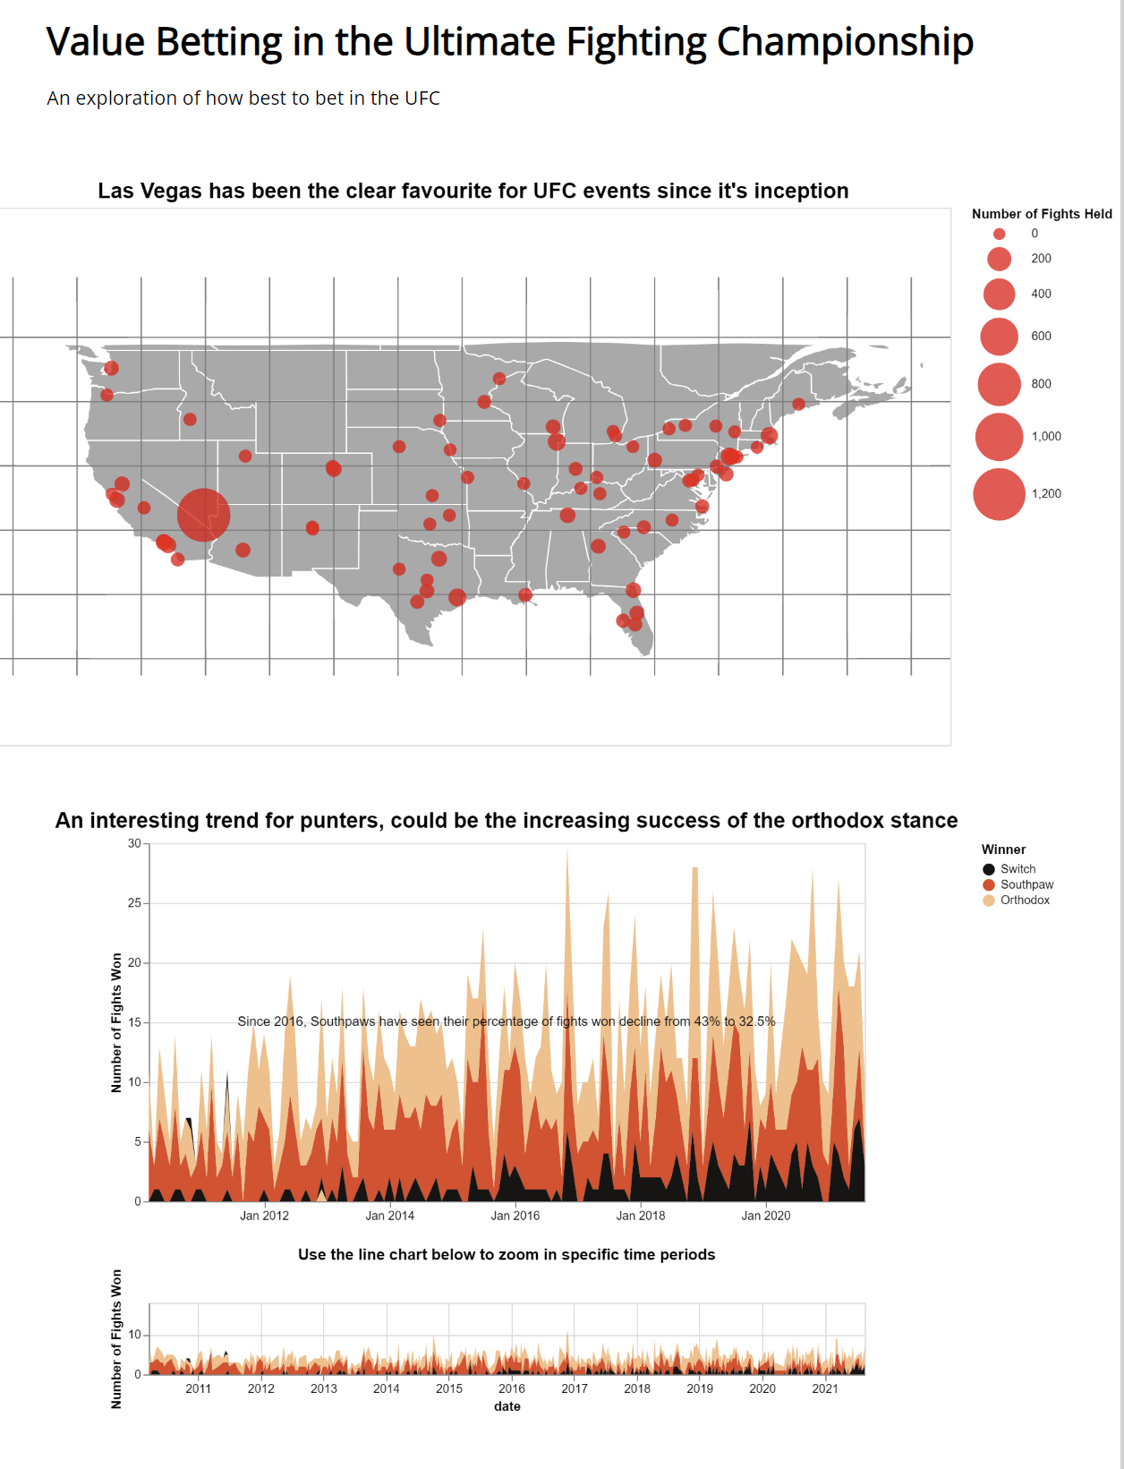<https://danigan99.github.io/FIT3179/>

My domain for DV2 is the UFC (Ultimate Fighting Championship)

The visualised dataset I used was: <https://www.kaggle.com/datasets/mdabbert/ultimate-ufc-dataset?select=ufc-master.csv>

I created a stacked area chart in order to encode the percentage of total fights (between two fighters with different stances) won by a fighter with each stance, as well as the raw numbers. Furthermore, I chose a stacked area chart as opposed to a stacked bar chart because I wanted users to be able to investigate this trend within year/monthly periods.